**UDACITY SELF DRIVING CAR NANODEGREE: TERM 3, Project 1: Path Planning Report**

**- Krithika Swaminathan(krswamin@umich.edu)**

Note: All this code also available on github repo

<https://github.com/rkyan13/Udacity-Self-Driving-Car-Projects/tree/feature-SCND-Term3-P1-Path-Planning>

Repository: <https://github.com/rkyan13/Udacity-Self-Driving-Car-Projects>

Branch Name: feature-SCND-Term3-P1-Path-Planning

**PROJECT SPECIFICATION: Path Planning**

**Compilation**

**CRITERIA-1 :**The code compiles correctly.

**MEETS SPECIFICATIONS**

Code must compile without errors with cmake and make. Given that we've made CMakeLists.txt as general as possible, it's recommend that you do not change it unless you can guarantee that your changes will still compile on any platform.

**Answer:** Please see attached screen shot that shows the code compiles correctly

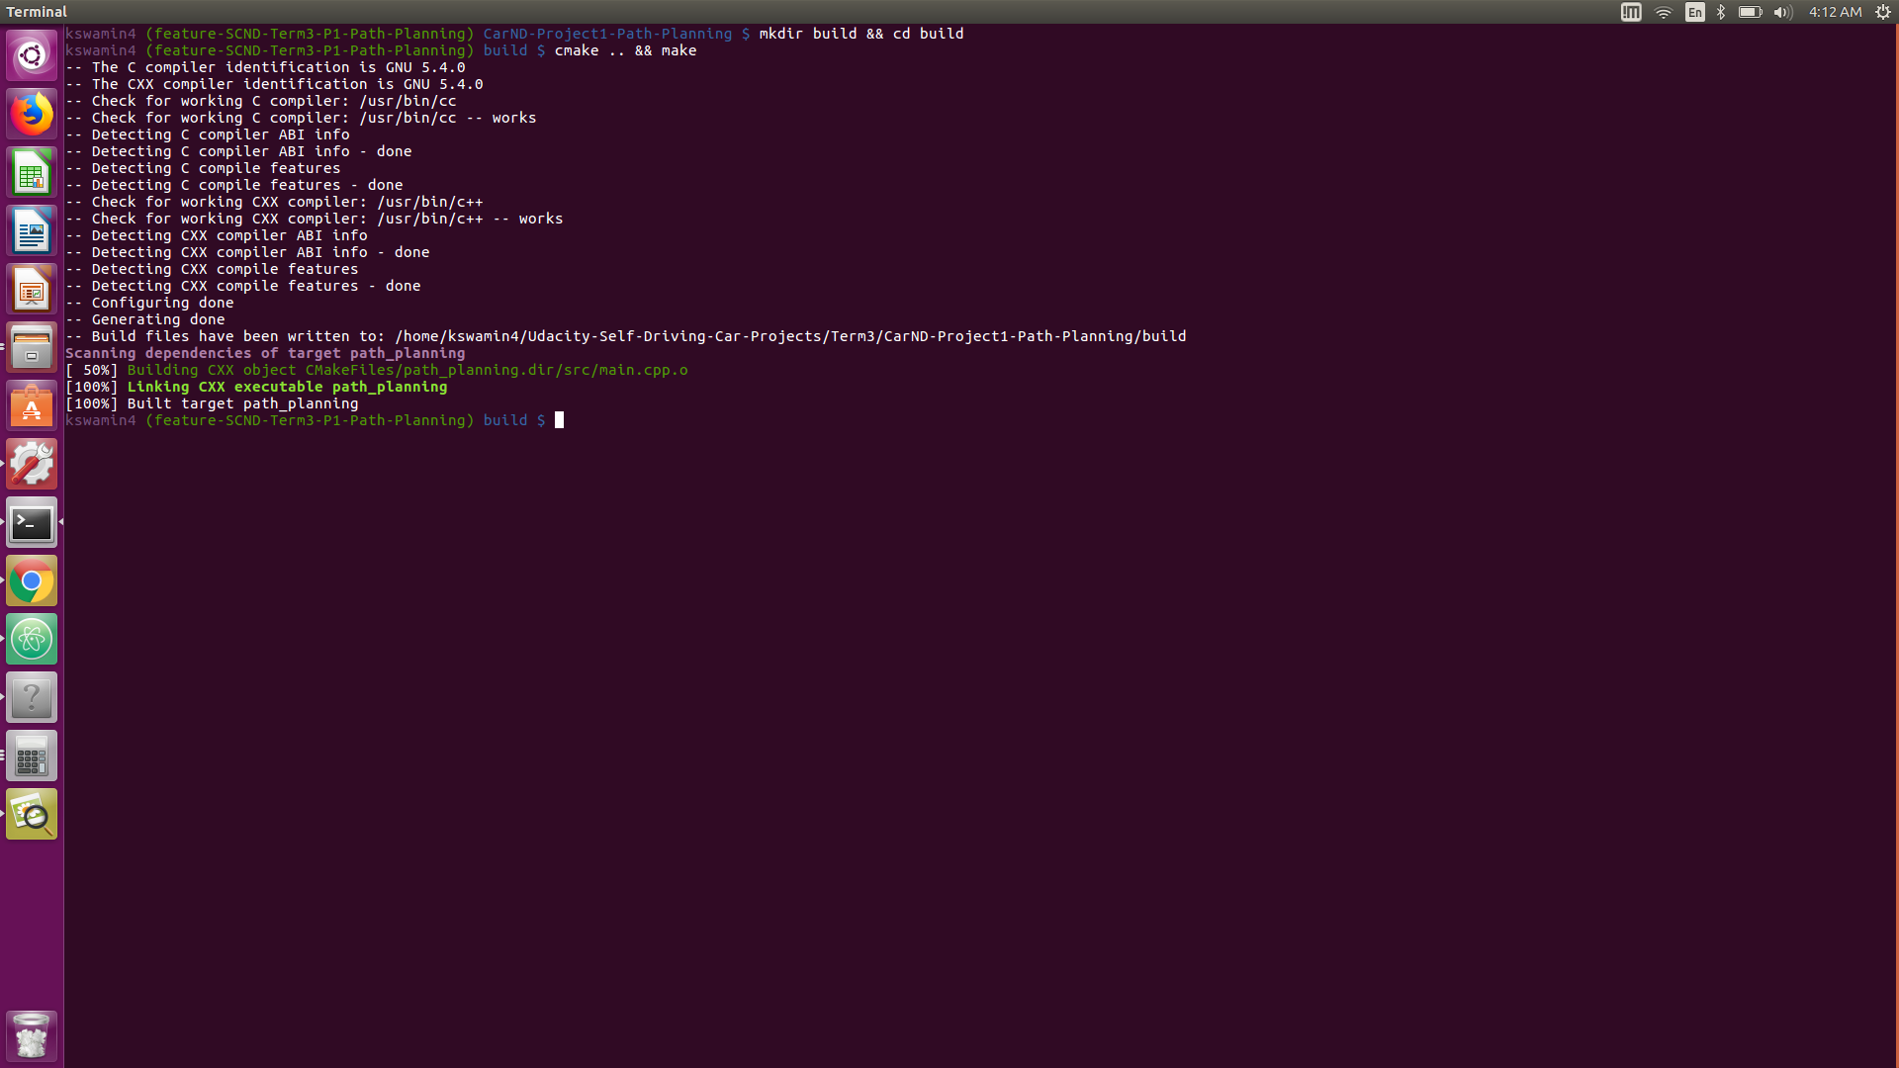

**Valid Trajectories**

**CRITERIA-2:** The car is able to drive at least 4.32 miles without incident.

**MEETS SPECIFICATIONS**

The top right screen of the simulator shows the current/best miles driven without incident. Incidents include exceeding acceleration/jerk/speed, collision, and driving outside of the lanes. Each incident case is also listed below in more detail.

**Answer:** see screen shots that show the car has driven atleast 4.32 miles without incident

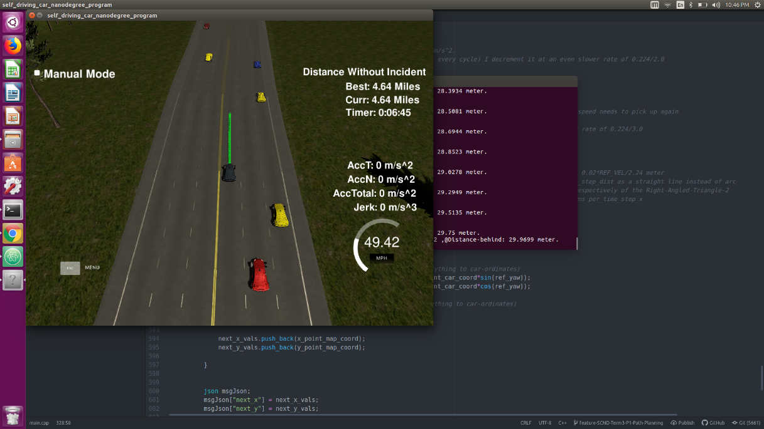 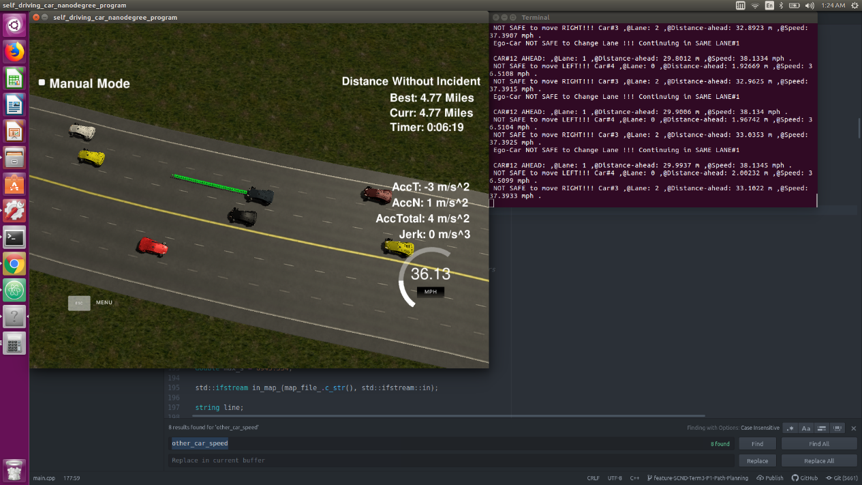

**Note to Grader/Reviewer: Occasional Rogue Car in Udacity Simulator: !!!!**

Once every 10-15 runs the udacity simulator seems to have a rogue car (usually yellow car) that seems to rapidly/rashly change 2 lanes at a time and collide with the ego car. I tried to reproduce the situation and move the ego_car away quickly to avoid collision. However such a quick response to the rogue is not possible without violating acceleration and jerk limits on an average . Hence I stuck to a more conservative model. Should a similar situation arise, that it is not the failure of my lane change /collision avoidance model. I request you to kindly restart the simulator and run the code again. (Kindly do not mark this criteria as a fail due to rogue collision !!!)

**CRITERIA-3 :** The car drives according to the speed limit.

**MEETS SPECIFICATIONS**

The car doesn't drive faster than the speed limit. Also the car isn't driving much slower than speed limit unless obstructed by traffic.

Answer:

1. In order to meet the speed limit of 50mph I’ve set the IDEAL_SPEED_LIMIT to 49.5mph (i.e. just below 50mph). The REF_VEL is the running reference velocity of the ego_car based on what other cars are around/ lane change situation etc. ***(See code lines approx.206 to 209)***



1. Nominally (when there aren’t slower cars ahead, when we aren’t changing lanes etc. ) We want the car to move at 49.5 mph(= 49.5/2.24 m/s). So the per_time_step_dist covered needs to be 0.02*REF_VEL/2.24 meter. This distance is an arc along the spline. This arc needs to be converted to x and y distances. I just coded this based on Udacity Aaron’s Code + Walk through video, using the concept of similar triangles. (See code lines approx. 640 to 665)

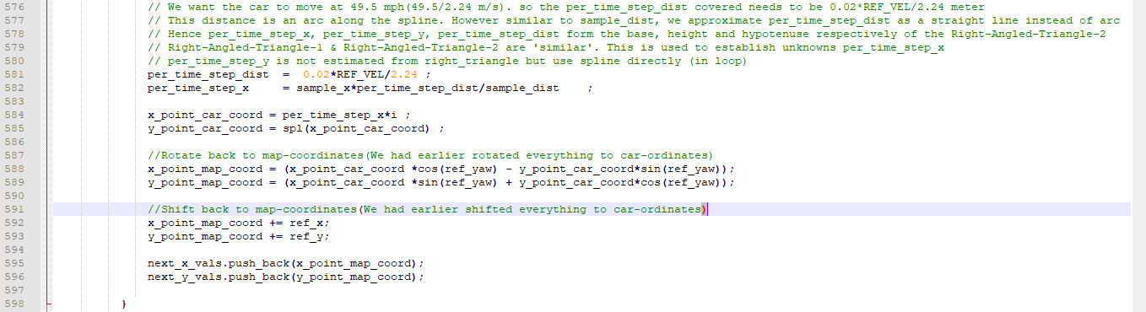

For more details on how the similar triangle and the spline works. **(See comments in code *lines approx. 590 to 606)***

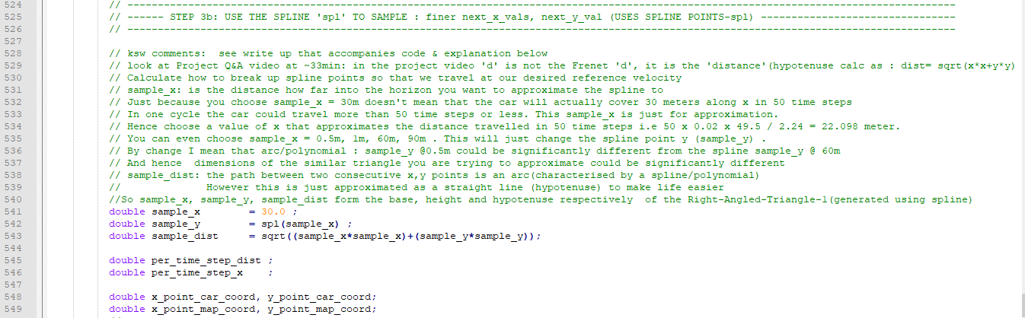

1. The ego velocity gradually reduces only if there a car ahead of it but never drops below the 93% of the speed of the car ahead of ego_car**(See code lines approx. 625 to 631)**

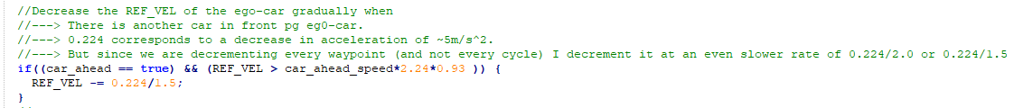

1. When the REF_VEL has fallen, based on the situation and if safe , increase the REF_VEL to meet the IDEAL_SPEED_LIMIT ***(See code lines approx. 632 - 639)***

Increase the REF_VEL of the ego-car gradually when

* when there is a cold start(starting at REF_VEL =0)
* if the ego-speed had fallen since there was a slower car in front of ego-car and the ego-speed needs to pick up again
* 0.224 corresponds to a increase in acceleration of ~5m/s^2
* But since we are incrementing every waypoint (and not every cycle) I increment it at a slower rate of 0.224/3.0

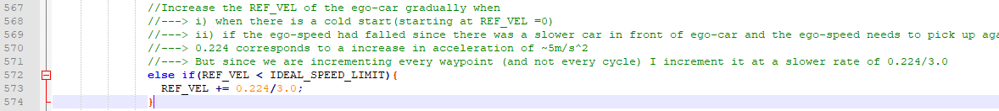

**Examples: Car Driving at Speed Limit both with and without traffic**

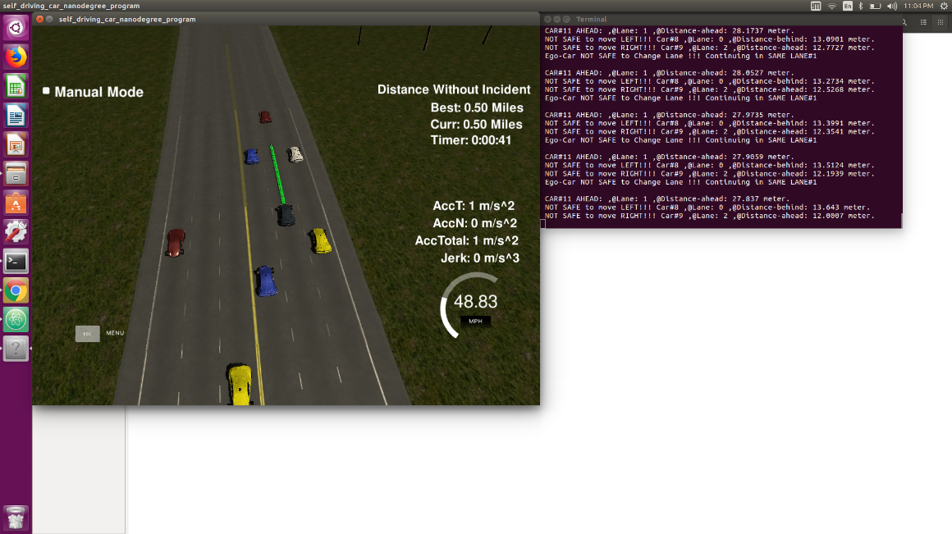 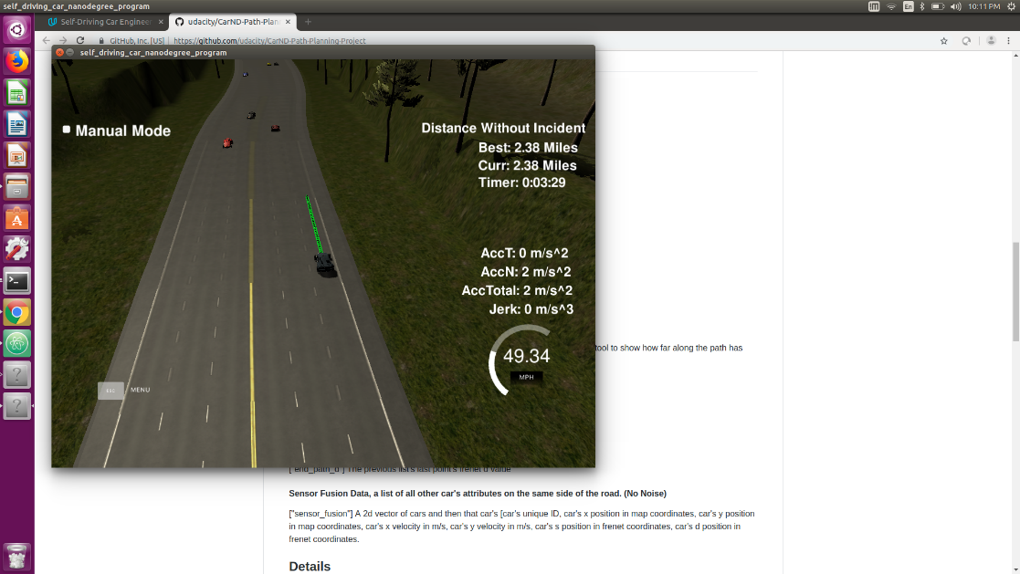

**Speed Limit Maintained With Traffic Speed Limit Maintained Without Traffic**

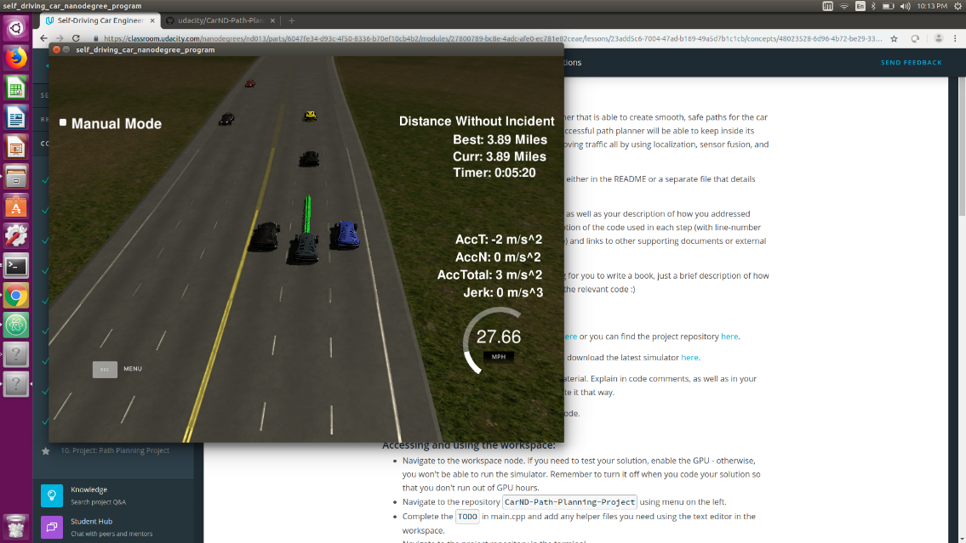

**Speed Limit Not Maintained only when obstructed by traffic**

(Note : I have improved the code further so that ego_car sticks closer to speed limit even when obstructed by traffic. So in the latest submitted version, the speed will probably be close to 35mph even when obstructed by traffic)

**CRITERIA-4:** Max Acceleration and Jerk are not Exceeded.

**MEETS SPECIFICATIONS**

The car does not exceed a total acceleration of 10 m/s^2 and a jerk of 10 m/s^3.

See explanation above. **Look at Code line 625 to 639.**

* When the ego_car needs to slow down because of a slower moving car ahead, I decrease the REF_VEL by 0.224 which corresponds to a deceleration of 5m/s^2. This is applicable if the REF_VEL is decremented every cycle. However I don’t decrement every cycle, I decrement it inside the path planner for every waypoint. Hence I make it even more conservative and decrease by only 0.224/1.5 so that acceleration and jerk limits are not violated
* Similarly when the ego_car needs to get back to Speed Limit of 49.5 mph either after a lane change or after a cold-start I increment REF_VEL by 0.224, if done every cycle . But when done inside the path planner for incrementing every way point a more conservative increment by 0.224/2.0 is better to avoid exceeding jerk limits
* The most important thing to remain within Jerk limits was to use the spline function. For details of this please refer Attempt 6 in the tabulated section below (Refer to code and comments Line 473 to Line 662)

**CRITERIA-5:** Car does not have collisions.

**MEETS SPECIFICATIONS**

The car must not come into contact with any of the other cars on the road.

**CRITERIA-6:** The car stays in its lane, except for the time between changing lanes.

**MEETS SPECIFICATIONS**

The car doesn't spend more than a 3 second length out side the lane lanes during changing lanes, and every other time the car stays inside one of the 3 lanes on the right hand side of the road.

**CRITERIA-7:** The car is able to change lanes

**MEETS SPECIFICATIONS**

The car is able to smoothly change lanes when it makes sense to do so, such as when behind a slower moving car and an adjacent lane is clear of other traffic.

Explanation of Criteria 5,6,7: Collision Handling and Lane Change Logic Explanation

**See Code Lines #305 to #470**

**General Logic for Collision Avoidance and Lane Change**

* If there is a slow moving car ahead of the ego_car in the same lane that breaches the safe distance parameter (SAFE_DIST_FROM_SAME_LANE_CARS = 30.0), the ego_car will change lanes as appropriate to either the left or right lane , whichever is clear of traffic . If that is not possible continue in the same lane at a lower speed, if neither left nor right lane is clear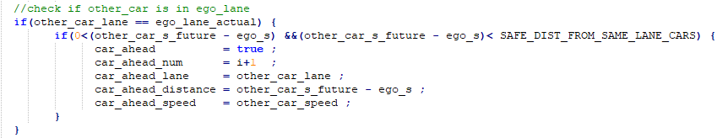
* For Cars moving in the adjacent lane to ego_car but ahead of it the safe-distance is specified by the parameter SAFE_DIST_FROM_ADJACENT_LANE_CARS_AHEAD = 40m. So Ego Car will not change lanes to the left or right if a car will be within 40m ahead of it (in the immediate future)
* Similarly For Cars moving in the adjacent lane to ego_car but ahead of it the safe-distance is specified by the parameter SAFE_DIST_FROM_ADJACENT_LANE_CARS_BEHIND = 17m. So Ego Car will not change lanes to the left or right if a car will be within 17m behind it (in the immediate future)

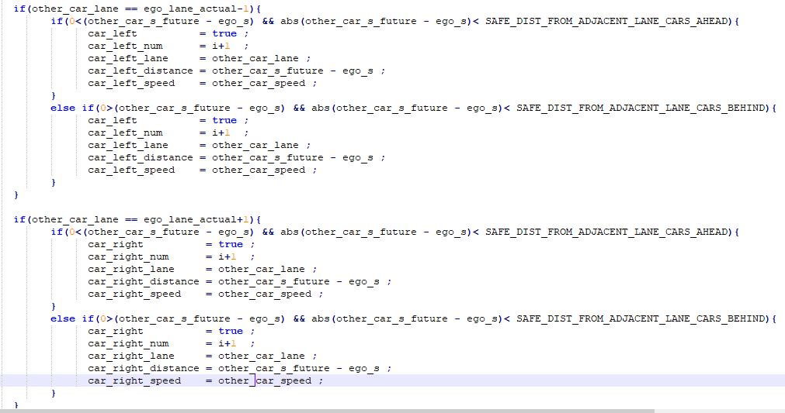

**Example Case: How Does this Logic and the values of these parameters facilitate Smooth Lane Change**

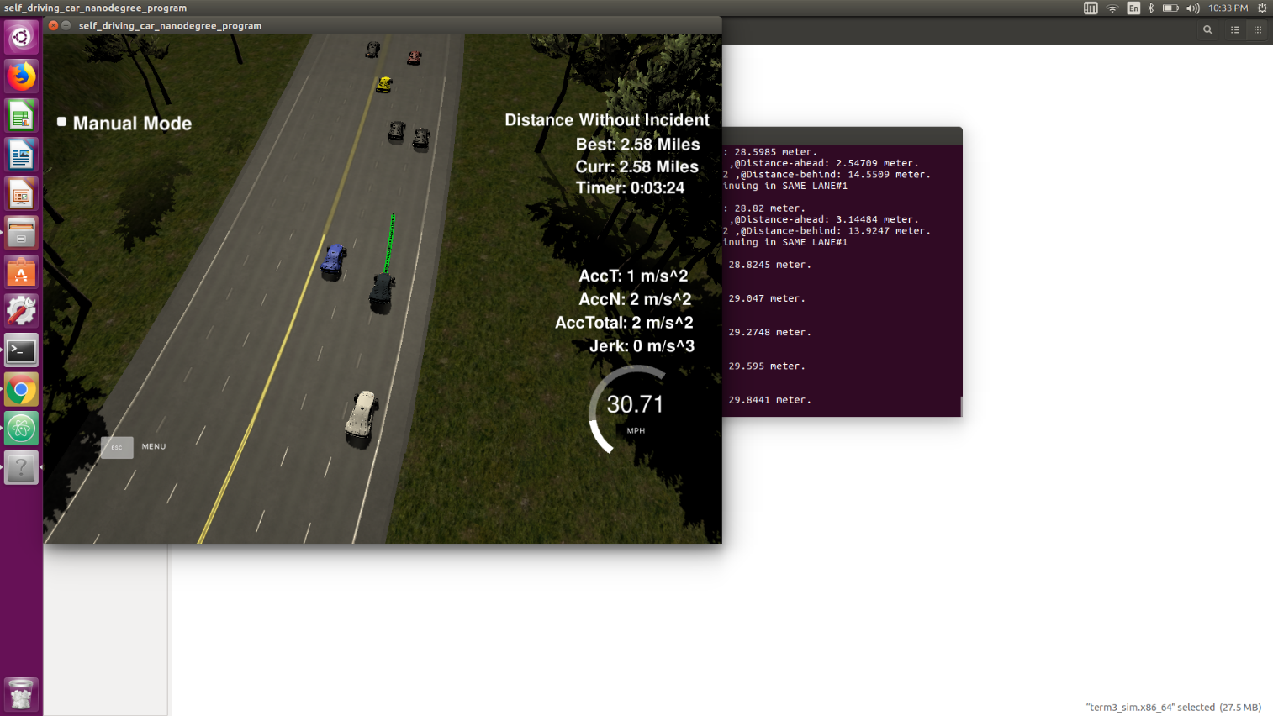

Illustration : cars at ~30m and ~32m ahead of ego car in same lane and adjacent lane respectively

* If there is a slower moving car at distance of <30m ahead the ego_car will attempt to change lanes to the left or right.In the previous version the code was written so that the adjacent car lanes also needed to be clear of cars only by 30meters to facilitate lane change. This caused sloppy lane changes.
* For example assume ego_car travelling in Lane2(the right most lane) encounters a slow moving car ~29 meters ahead. Also assume there is a slow moving car ~32 metres ahead of ego_car but on the Middle Lane (Lane 1) i.e. to the left of the ego car. The ego_car would move left from Lane-2(right lane) to Lane-1(middle lane) only to realise very quickly the car in Lane-1(Middle lane) is also slow moving and jump back to Lane-1 . This would cause the ego_car to straddle lanes/ keep hopping between lanes etc.
* In order to facilitate smoother lane change I added the following parameters, SAFE_DIST_FROM_SAME_LANE_CARS = 30.0, SAFE_DIST_FROM_ADJACENT_LANE_CARS_AHEAD = 40 & SAFE_DIST_FROM_ADJACENT_LANE_CARS_BEHIND =17 (I spent a fair amount of time fine tuning the values). This way the ego_car will change lanes only if the adjacent lanes are clear of traffic 40m ahead (i.e more than the same_lane clearance of 30m) since there is really no point in changing lanes and landing in a similar situation
* Also 30m for checking for cars behing the ego_car in adjacent lanes was too much making lane change tooo conservative and frustrating. So I fine tuned SAFE_DIST_FROM_ADJACENT_LANE_CARS_BEHIND to 17m using trial and experimentation

**Example : Ego_car will not change lane to left or right since it is unsafe to do, but will follow slower moving red car ahead.**

Red car at 36-37mph and ego car following behind at 34mph

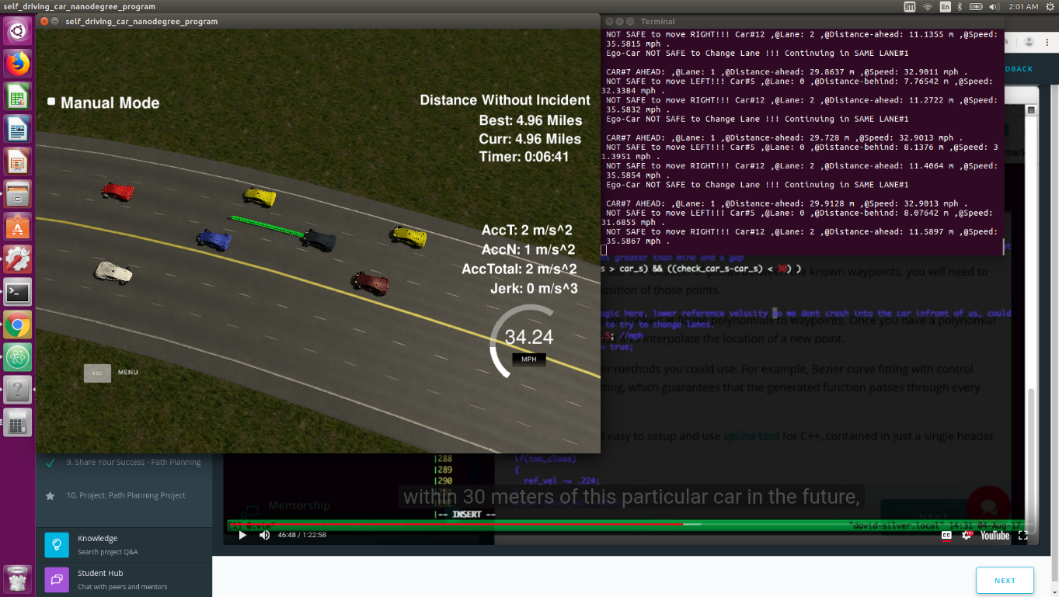

**Example : Sloppy Lane Change in previous versions of code fix. (This no longer happens in final version)**

Ego_car is behind slow moving blue car and tried to change lanes to left behind black car. But it soon realizes Black car is slow moving too and might attempt to hop back under blue.

Hence added SAFE_DIST_FROM_SAME_LANE_CARS = 30.0, SAFE_DIST_FROM_ADJACENT_LANE_CARS_AHEAD = 40 & SAFE_DIST_FROM_ADJACENT_LANE_CARS_BEHIND =17 to take care of this issue. Car will no longer attempt to change lanes in similar situation below but will continue driving in same lane

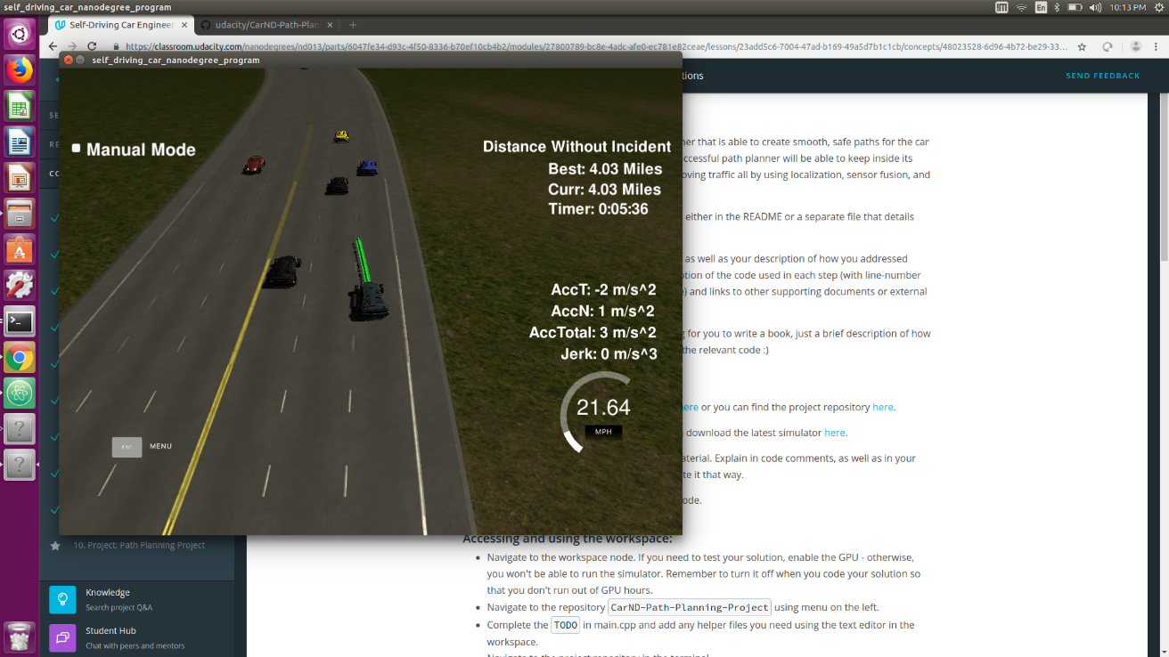 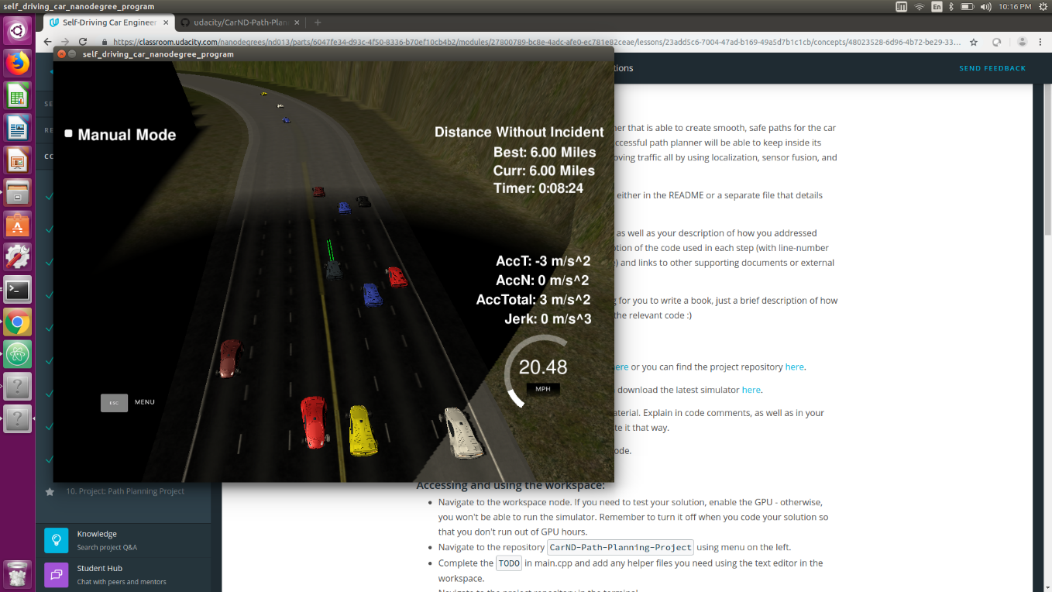

**BEFORE FIX: Ego car sloppy lane change**  **AFTER FIX: Ego Car does not Change Lane**

**FUTURE IMPROVEMENTS TO THE CODE**

I’ve not addresses these improvements in the final submitted code main.cpp since the Project Rubric doesn’t require these, and also didn’t fine tune them in the interested of time

However, I’ve implemented some of the improvements in Additional-Files/main-v11a.cpp just as a means of exploration/ fun, not for project evaluation. Hence main-v11a doesn’t consider/satisfy all the rubric points . If interested please replace main.cpp with main-v11a.cpp and see how well it does. (or checkout corresponding commit from github –repo)

**Improvement 1: Lane Change is Too Conservative:**

With the given acceleration and jerk limits, this was the best fine tuning that I could do. Perhaps with a more sophisticated model that gives me control over not just the REF_VEL but also over brake etc. and also by occasionally relaxing acceleration and jerk limits a more real-life city type of lane change is possible .

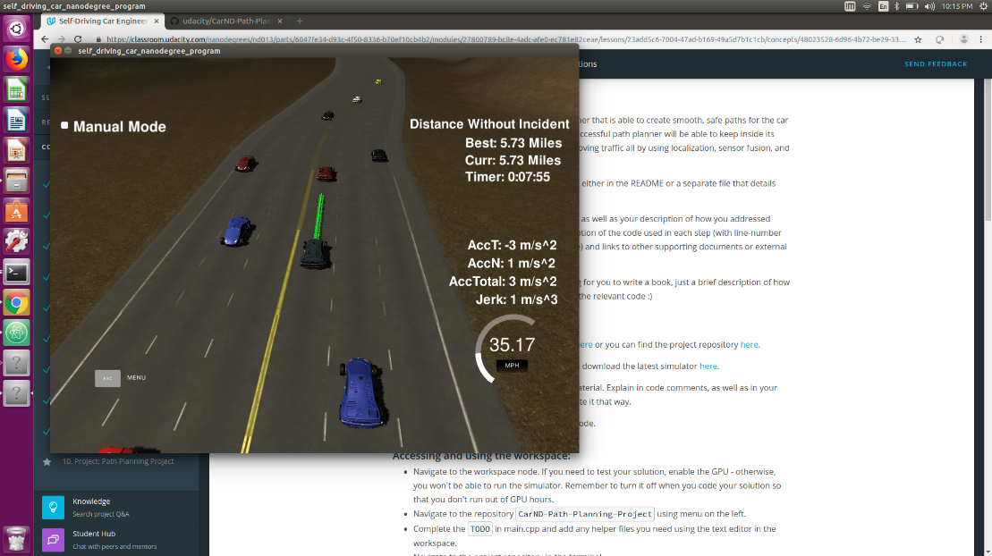

Ego won’t change lanes because blue car on right lane is <15m (within 15 m now and immediate future) behind

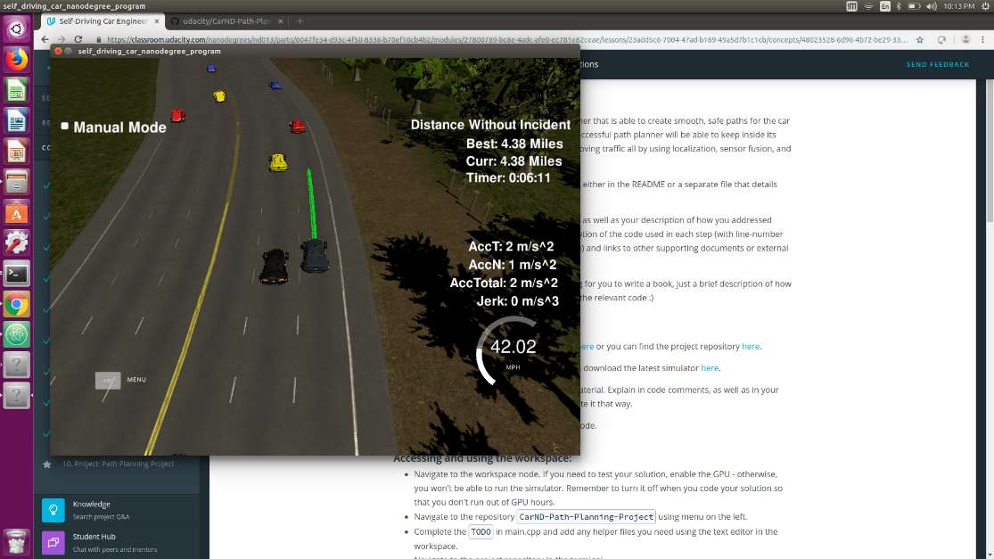

Ego won’t cut in between black and yellow cars on left and move to highest speed lane

**Improvement 2: Ability to Change more than 1 lane at a time (to prevent Stalemate)**

In the following figures the car ahead of ego car and the car in the adjacent right lane are moving slowly. The right most lane is free. But at the moment the Ego car is able to check for conditions and change lanes only to the adjacent lane and hence cannot move to the right most lane quickly from the left most lane. So if the cars ahead move slowly the ego car will follow them for a while (similar to adaptive crusie control ) and make a lane change only when appropriate

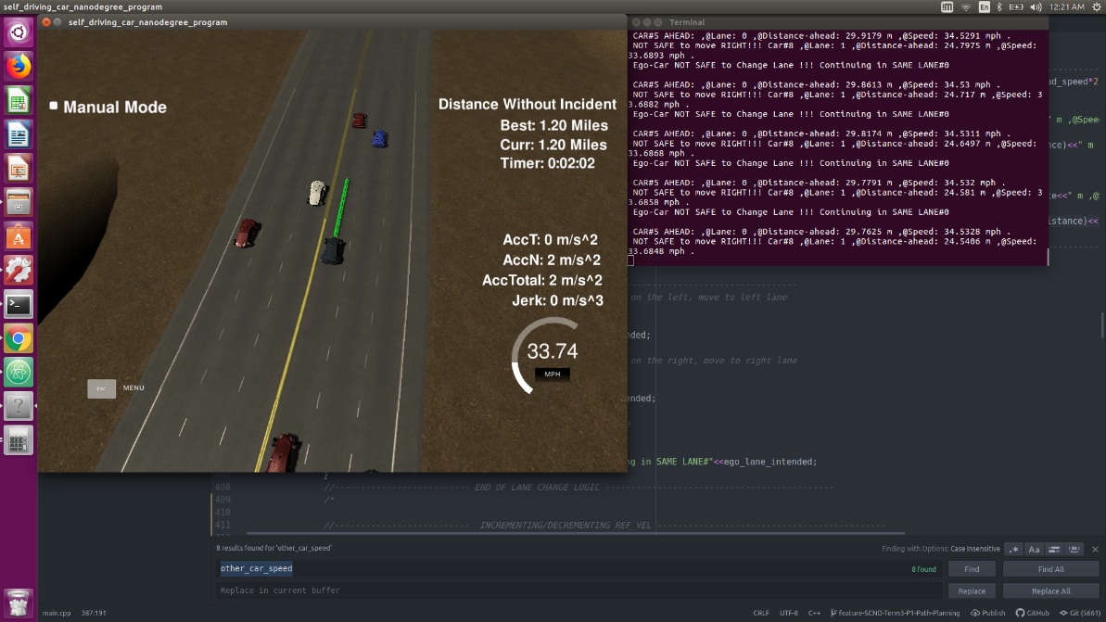 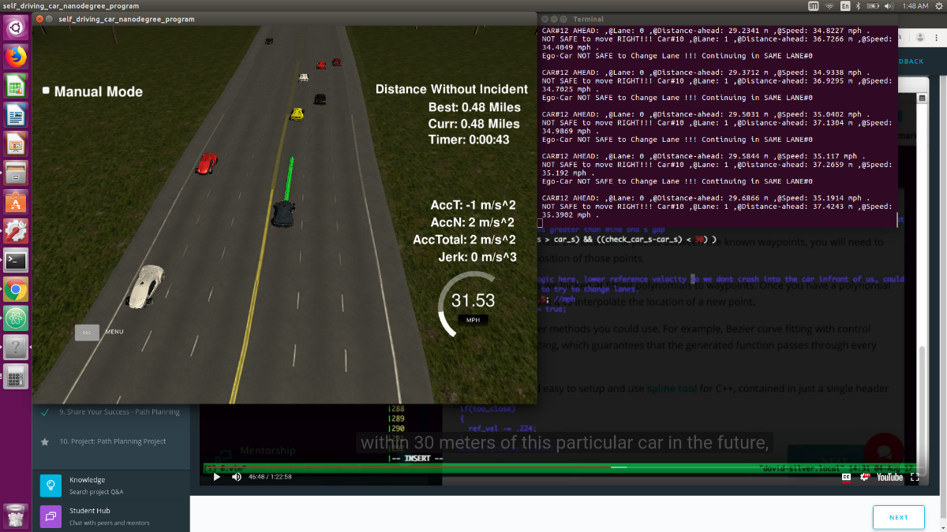

**Improvement 3: Consciously move away from high speed lane/ low speed lane to the center lane**

Once the ego_car gets on the high speed lane/ low speed lane, it will not move back to the center lane unless it is being impeded by a slower moving car. It will be nice if the car can by default drive on the center lane as a courtesy to fellow drivers (like how it should drive in real life). This has been implemented in additional code main-v11a.cpp(but not in the submitted main.cpp)

**Reflection**

**CRITERIA-8:** There is a reflection on how to generate paths.

**MEETS SPECIFICATIONS**

The code model for generating paths is described in detail. This can be part of the README or a separate doc labeled "Model Documentation".

**Answer:**

* The most important for the path generation is the use of spline. For details of this please refer Attempt 6 in the tabulated section below (Refer to code and comments Line 473 to Line 662)
* Collision handling and Lane Change is also important for generation path (already discussed above)
* The step by step procedure of how I did it is tabulated below. I’ve also detailed these steps in the comments section at the beginning of main.cpp I followed the Walkthrough Video + Aaron’s code in the Project Lessons to build the Path Planner step by step. I made suitable modifications/fine tunings at each step

Notes to self:

* in Frenet co-ordinates d is lateral distance, s is vertical distance along the length of the road
* d-value for lanes
  + - 0
    - LeftLane: Lane#0: (1,2,3),
    - 4
    - MiddleLane: Lane#1: (5,6,7),
    - 8
    - RightLane: Lane#2: (9,10,11),
    - 12
* previous_path_x, previous_path_y DO-NOT INCLUDE ALL the points generated the previous cycle. They only consist of the remainder of the path points that the car did not use/did not travel in the previous cycle

|  |  |
| --- | --- |
| **Attempt #** | **Incremental Code Improvement Details at Each Attempt in main.cpp code**  Note: To see these step by step versions please checkout the corresponding commit on github repo or use the corresponding main-vX.cpp files from ‘Additional-Files’ folder(provided in the zip)  Repository: <https://github.com/rkyan13/Udacity-Self-Driving-Car-Projects>  Branch Name: feature-SCND-Term3-P1-Path-Planning |
| Attempt 0 | Download base code from udacity github repo |
| Attempt 1 | Make car drive in straight line, based on udacity code  See Lesson 6: Path Planning Project/ Concept 2-Getting Started    **What happens in this attempt:**  Car attempts to drive in straight line, but car over shoots road |
| Attempt 2 | Make car drive in circular path, based on udacity code  See Lesson 6: Path Planning Project/ Concept 2-Getting Started  **What happens in this attempt:**  Car drives in circular path (just for fun)  First Attempt at using previous_path points |
| Attempt 3 | Make car drive in straight line along 's' |
| Attempt 4 | Make car drive in straight line along 's' using speed equations(no acceleration), car path explodes |
| Attempt 5 | Attempt at lane keeping (drive in straight line along s) using speed and acceleration limits.   * Car maintains lane However car still exceeds speed, accel and jerk limits several times * Polynomial Lane Generation /Spline not used: Possible use of this can keep accel and jerk within limits * Car Collision not handled   *(Check out the corresponding version of the code from github or use Additional-Files/main-v5.cpp to see code snippets below)*  Set limits on speed and acceleration    Attempt at Lane Keeping along 's' using speed and acceleration limits |
| Attempt 6 | Attempt at lane keeping (drive in straight line along s) using spline. Based on Udacity's Aaron's Code  *(Check out the corresponding version of the code from github or use main-v6p5.cpp to see code snippets below)*  Logic:  **STEP 1: CREATE 5 POINTS SPACED FAR APART : GENERATE ptsx & ptsy:** so this will be  (ptsx &,ptsy)= 5 points = {(ref_x,ref_y), (ref_prev_x,ref_prev_y), getXY(ego_s_30),getXY(ego_s_60),getXY(ego_s_90)}          **STEP 2: CREATE SPLINE : FROM THE FAR SPACED 5 POINTS**  spl = spline-from(ptsx,ptsy)    **STEP 3: CREATE THE ACTUAL PATH POINTS:** next_x_vals, next_y_vals for the Path Planner  **STEP 3a: USE previous_path POINTS TO CREATE** :next_x_vals, next_y_vals (DOES NOT USE THE SPLINE POINTS-spl)  ---> This step does not require the use of the newly generated spline, we just use the previous_path_x & previous_path_y.  ---> However spline could have been used to generate previous_path_x & previous_path_y (in the previous cycle of course)  ---> Note: previous_path_x, previous_path_y DO-NOT INCLUDE ALL the points generated the previous cycle.  They only consist of the remainder of the path points that the car did not use/did not travel in the previous cycle    **STEP 3b: USE THE SPLINE 'spl' TO SAMPLE : finer next_x_vals, next_y_val**  Ideally the distance we'd like to move every time step to maintain speed limit is per_time_step_dist = 0.02*REF_VEL/2.24  But we need a way to map this 'per_time_step_dist ' to x & y co-ordinates on a curved road.  We achieve this using the spline points and 2-similar-triangles. See the code comments for more details      **Resolved Issues:**  Car maintians speed, accel and jerk limits (exceeds accel and jerk only during cold start i.e)  **Issues to address:**  i) Handle accel and jerk exceeding during cold start  ii) Handle collisions  iii) Handle Lane Changes |
| Attempt 7a | **Attempt at Handling Collisions**  **Resolved Issues:**  Ego car does not collide: slows down to 29.5 mph if there is a car in front  (but ego-car reference velocity keeps changing from 29.5 to 49.5 mph every cycle. Quite irritating !!!) *(Check out the corresponding version of the code from github or use main-v7a.cpp to see code snippets below)*    **Issues to address:**  i) Handle collisions in a better way  --> ego-car velocity keeps changing from 29.5 to 49.5 mph every cycle  --> ego-car slows down to 29.5 mph but never picks up the speed back to 49.5 mph  ii) Handle accel and jerk exceeding during cold start  iii) Handle Lane Changes |
| Attempt 7b | **Attempt at Handling Collisions**  **Resolved Issues:**   * Resolved the velocity changing from 29.5mph to 49.5 mph every cycle.Now ego-car-velocity remains at 29.5mph every cycle * Moved the following piece of code from inside int main()/h.onMessage(...) to outside int main()   //start in ego_lane 1  int ego_lane = 1;  //have a reference velocity to target  double REF_VEL = 49.5 ; //mph  *(Check out the corresponding version of the code from github or use main-v7b.cpp to see code snippets below)* |
| Attempt 7c | **Attempt at Handling Collisions**  Car slows down to the 0.9*speed-of-car-in-front instead of a standard (29.5mph) |
| Attempt 8a | **Collision Avoidance & Cold Start : Slow-Down, Speed up Gradually (EVERY CYCLE, OUTSIDE PATH PLANNER)**  **Resolved Issues:**  **i) Collision Handling: Smooth Acceleration/Deceleration & Jerk Minimization**  ---> Ego car does not collide  ---> Ego car slows down GRADUALLY @REF_VEL -= 0.224(deceleration 5m/s^2) every cycle(outside path planner)  ---> Once the slow moving car has passed the ego-car gradually ramps up to IDEAL_SPEED_LIMIT @REF_VEL -= 0.224(acceleration 5m/s^2) every cycle(outside path planner)  **ii) Cold Start Jerk Minimization**  ---> Car will start at 0 and gradually ramp up to IDEAL_SPEED_LIMIT @REF_VEL -= 0.224(acceleration 5m/s^2) every cycle (outside path planner)    **Issues to address:**  i) Increment/Decrement the ego-speed(i.e the REF_VEL) every way-point,inside the path-planner (instead of doing it every cycle outside the path planner)  ii) Handle lane Changes |
| Attempt 8b: | **Collision Avoidance & Cold Start : Slow-Down, Speed up Gradually (EVERY WAYPOINT, INSIDE PATH PLANNER)**  **Resolved Issues:**  **i) Increment/Decrement the ego-speed(i.e the REF_VEL) every way-point,inside the path-planner loop (instead of doing it every cycle outside the path planner)**  But Increment/Decrement-ing REF_VEL @0.224 every way-point causes jerk issues + collisions.  Hence ---> I decrement REF_VEL at a slower rate of 0.224/2.0, &  ---> I increment REF_VEL at a slower rate of 0.224/3.0    **Issues to address:**  i) Handle lane Changes |
| Attempt 9 | **First take on Lane change (See project Q&A 52.30min to 57min )**  i) If there is is a slow moving car ahead, ego_car will move to the left lane (if left lane exists)  **Issues to address:**  i) Does not check if it is safe to change lanes. i.e does not check if car on left lane is within colliding distance, just blindly changes lane |
|  | **Rubric Passing Version with Good Lane Changes !!!!**  i) If there is is a car ahead, ego_car will change lanes to as appropriate left or right lane whichever is clear of traffic  (or continue in the same lane, if neither left nor right lane is clear)  (See Lane Change Logic Section above)  **Possible Improvements**  i) If Ego-Car is in High-Speed-Left-Lane(Lane0) or Low-Speed-Right-Lane(Lane2), it does not make an effort to get back to Center-Lane1 |
| **ATTEMPT 10b: Final SUBMITTED VERSION** | |
|  | Attempt 10b: Rubric Passing Version with Cleaner Lane Changes and Better Collision Avoidance  **Resolved issues**  i) Better Speed Limit Maintenance by ego_car  Changed the following line of code  if((car_ahead == true)  to  if((car_ahead == true) && (REF_VEL > car_ahead_speed*2.24*0.93 )) to ensure that the speed of the ego_car never drops below 93% of the car_ahead.  Without this change the ego_car speed would often drop dangerously low to values as low as 15mph making lane change impossible/dangerous and would also lead to collisions  **ii) Smoother Lane changes**  If there is a slower moving car at distance of <30m ahead the ego_car will attempt to change lanes to the left or right.In the  previous version the code was written so that the adjacent car lanes also needed to be clear of cars only by 30meters to facilitate lane change.  This caused sloppy lane changes.  For example assume ego_car travelling in Lane2(the right most lane) encounters a slow moving car ~29 meters ahead.  Also assume there is a slow moving car ~32 metres ahead of ego_car but on the Middle Lane (Lane 1) i.e. to the left of the ego car  The ego_car would move left from Lane-2(right lane) to Lane-1(middle lane) only to realise very quickly the car in Lane-1(Middle lane)  is also slow moving and jump back to Lane-1 . This would cause the ego_car to straddle lanes  In order to facilitate smoother lane change I added the following parameters  SAFE_DIST_FROM_SAME_LANE_CARS = 30.0  SAFE_DIST_FROM_ADJACENT_LANE_CARS_AHEAD = 40 & SAFE_DIST_FROM_ADJACENT_LANE_CARS_BEHIND =17 (I spent a fair amount of time fine tuning the values)  This way the ego_car will change lanes only if the adjacent lanes are clear of traffic 40m ahead (i.e more than the same_lane clearance of 30m) since there is really  no point in changing lanes and landing in a similar situation  Also 30m for checking for cars behing the ego_car in adjacent lanes was too much making lane change tooo conservative and frustrating.  So I fine tuned SAFE_DIST_FROM_ADJACENT_LANE_CARS_BEHIND to 17m using trial and experimentation |

**Suggestions to Make Your Project Stand Out!**

Create a path planner that performs optimized lane changing, this means that the car only changes into a lane that improves its forward progress:

**Answer:** See Additional-Files/ main-v11a.cpp (not for evaluation, just exploratory)

**Attempt 11a: Ego-car tries to get back to center lane after passing cars**

i) If there is is a car ahead, ego_car will change lanes to as appropriate left or right lane whichever is clear of traffic

(or continue in the same lane, if neither left nor right lane is clear)

ii) If Ego-Car is in High-Speed-Left-Lane(Lane0) or Low-Speed-Right-Lane(Lane2), it makes an effort to get back to Center (but need to fine tune this further)

**============== THE HAPPY ENDING ☺ ==================**